# Event Overviews

The **[Data Visualization Masterclass](https://datavismasterclass.org/de/heidelberg)** is a highly regarded professional training series, held at global locations over the past ten years as a satellite event to the international meetings on Visualizing Biological Data ([VIZBI](https://vizbi.org/)), and supported by the International Society for Computational Biology ([ISCB](https://www.iscb.org/)). The Masterclass features renowned experts who distill decades of experience into a compact format. Participants gain essential skills to uncover insights from complex data, validate AI-driven findings, and effectively communicate their results.

# Key Benefits for Attendees

* Master Best Practices: Gain hands-on knowledge of advanced data visualization principles, strategies, and tools directly applicable to your work.
* Expert Guidance: Learn from a world-renowned expert with decades of experience in visualizing complex data.
* Professional Growth: Enhance your ability to validate datasets, interpre[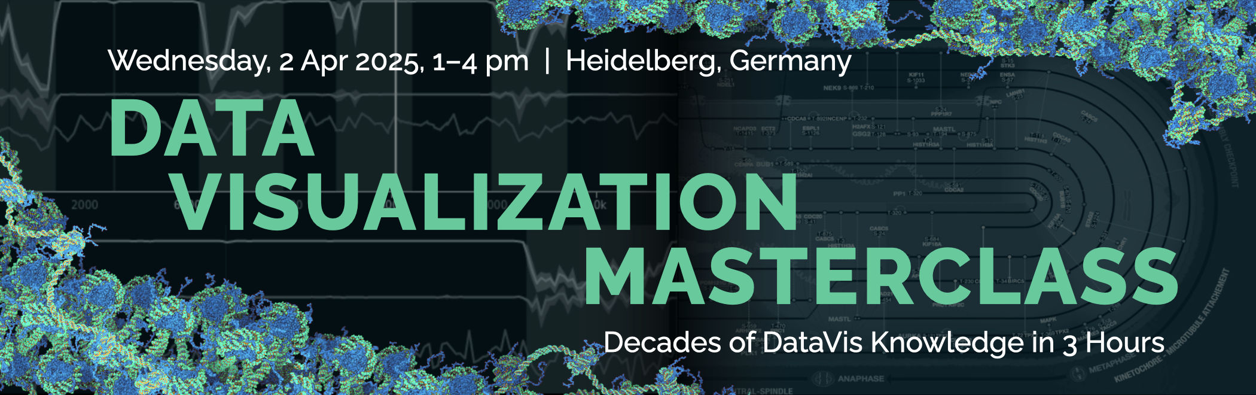](https://datavismasterclass.org/de/heidelberg)t AI-driven insights, and craft compelling data-driven narratives.
* Interactive Learning: Present your challenges in lightning talks to receive tailored feedback from the instructor and peers.
* Certification: Receive a completion certificate to support your professional development goals.

# Practical Applications

* Design clear, impactful visualizations for complex datasets.
* Communicate findings effectively to diverse audiences.
* Navigate challenges like multimodal data integration and data storytelling.
* Optimize visual designs for accessibility and engagement.

# Pricing and Registration

* Cost: industry: €300, academics/freelancer: €225, student/unemployed: €150
* Location: Karlstorkino, Medienforum Heidelberg, Germany.
* Date and Time: Wednesday, 2 April 2025 | 1:00 PM – 4:00 PM.
* Registration: Reserve your spot using the link below.